**[ Android 숫자 야구 게임 ]**

**● Contents : ① Architecture & Data Structure ② Protocol ③ DB schema ④ Data Flow Chart between Client and Client Manager**

**① Architecture & Data Structure**

**Android Client 1 (Java)**

**Client 1**

**Android Client 1 (Java)**

**Client 1**

**Protocol Buffer**

**Login Server (Proactor IOCP)**

**DB ( MySQL )**

**DB Manager**

**Thread**

**Process (C++ Proactor IOCP)**

df

**Client Manager**

**Thread**

**Shared Data**

**Browser ( HTML 5 )**

**Monitering Server (언어미정)**

**Struct < Player >**

**1. ID**

**2. State**

**3. Room Number**

**Struct < Status >**

**1. Win / Lose Cnt**

**2. Strike / Ball Cnt**

**3. Out Cnt**

**Struct < Room >**

**1. State**

**2. Room Number**

**3. Joinners ( str [2] )**

**4. Round Cnt**

**5. Score (int, int)**

**6. Rand Num (int, int)**

**Struct < Record >**

**1. Time Stamp**

**2. Connected User Cnt**

**Data Structures**

**②Protocol**

**namespace PACKET_TYPE**

**{**

**enum C2LS**

**{**

**LOGIN_REQUEST = 0,**

**ACCOUNT_CREATE,**

**END**

**};**

**enum LS2C**

**{**

**LOGIN_SUCCESS = C2LS::END,**

**LOGIN_FAILED,**

**ACCOUNT_CREATE_SUCCESS,**

**ACCOUNT_CREATE_FAILED,**

**END**

**};**

**enum C2S**

**{**

**ROOM_CREATE = LS2C::END,**

**ROOM_JOIN,**

**ROOM_LEAVE,**

**REQUEST_INGAME_START,**

**SEND_BASEBALL_NUMBER,**

**END**

**};**

**enum S2C**

**{**

**ROOM_CREATE_SUCCESS = C2S::END,**

**ROOM_CREATE_FAILED,**

**ROOM_JOIN_SUCCESS,**

**ROOM_JOIN_FAILED,**

**ROOM_LEAVE_SUCCESS,**

**ROOM_LEAVE_FAILED,**

**INGAME_START_SUCCESS,**

**INGAME_START_FAIELD,**

**RECEIVE_BASEBALL_NUMBER_SUCCESS,**

**RECEIVE_BASEBALL_NUMBER_FAIELD,**

**INGAME_GIVE_TURN,**

**INGAME_WAIT_TURN,**

**INGAME_END,**

**END**

**};**

**};**

**namespace FAIL_SIGNAL**

**{**

**enum ACCOUNT**

**{**

**NO_EXIST,**

**ALREADY_EXIST,**

**WRONG_PASSWORD,**

**END**

**};**

**enum ROOM**

**{**

**ALREADY_EXIST = ACCOUNT::END,**

**FULL_ROOM,**

**END**

**};**

**enum IN_GAME**

**{**

**NO_EXIST_OPPONENT = ROOM::END,**

**EXIST_REPETITION_NUMBER,**

**END**

**};**

**};**

**/// ---------- CLIENT <-> LOGIN SERVER ----------- ///**

**struct CLS_LOGIN_REQUEST**

**{**

**unsigned short TYPE;**

**char ID[MAX_ID_SIZE];**

**char PASSWORD[MAX_PASSWORD_SIZE];**

**};**

**struct CLS_ACCOUNT_CREATE**

**{**

**unsigned short TYPE;**

**char ID[MAX_ID_SIZE];**

**char PASSWORD[MAX_PASSWORD_SIZE];**

**};**

**struct LSC_LOGIN_SUCCESS**

**{**

**unsigned short TYPE;**

**};**

**struct LSC_LOGIN_FAILED**

**{**

**unsigned short TYPE;**

**unsigned short FAIL_SIGNAL;**

**};**

**struct LSC_ACCOUNT_CREATE_SUCCESS**

**{**

**unsigned short TYPE;**

**};**

**struct LSC_ACCOUNT_CREATE_FAILED**

**{**

**unsigned short TYPE;**

**unsigned short FAIL_SIGNAL;**

**};**

**/// ---------- CLIENT <-> GAME SERVER ----------- ///**

**struct CS_ROOM_CREATE**

**{**

**unsigned short TYPE;**

**unsigned short ROOM_NUM;**

**char ID[MAX_ID_SIZE];**

**};**

**struct CS_ROOM_JOIN**

**{**

**unsigned short TYPE;**

**unsigned short ROOM_NUM;**

**char ID[MAX_ID_SIZE];**

**};**

**struct CS_ROOM_LEAVE**

**{**

**unsigned short TYPE;**

**unsigned short ROOM_NUM;**

**char ID[MAX_ID_SIZE];**

**};**

**struct CS_REQUEST_INGAME_START**

**{**

**unsigned short TYPE;**

**unsigned short ROOM_NUM;**

**char ID[MAX_ID_SIZE];**

**};**

**struct CS_SEND_BASEBALL_NUMBER**

**{**

**unsigned short TYPE;**

**unsigned short ROOM_NUM;**

**char ID[MAX_ID_SIZE];**

**unsigned short BASEBALL_NUM;**

**};**

**struct SC_ROOM_CREATE_SUCCESS**

**{**

**unsigned short TYPE;**

**};**

**struct SC_ROOM_CREATE_FAILED**

**{**

**unsigned short TYPE;**

**unsigned short FAIL_SIGNAL;**

**};**

**struct SC_ROOM_JOIN_SUCCESS**

**{**

**unsigned short TYPE;**

**};**

**struct SC_ROOM_JOIN_FAILED**

**{**

**unsigned short TYPE;**

**unsigned short FAIL_SIGNAL;**

**};**

**struct SC_ROOM_LEAVE_SUCCESS**

**{**

**unsigned short TYPE;**

**};**

**struct SC_ROOM_LEAVE_FAILED**

**{**

**unsigned short TYPE;**

**unsigned short FAIL_SIGNAL;**

**};**

**struct SC_INGAME_START_SUCCESS**

**{**

**unsigned short TYPE;**

**};**

**struct SC_INGAME_START_FAIELD**

**{**

**unsigned short TYPE;**

**unsigned short FAIL_SIGNAL;**

**};**

**struct SC_RECEIVE_BASEBALL_NUMBER_SUCCESS**

**{**

**unsigned short TYPE;**

**unsigned short JUDGE_STATUS;**

**};**

**struct SC_RECEIVE_BASEBALL_NUMBER_FAIELD**

**{**

**unsigned short TYPE;**

**unsigned short FAIL_SIGNAL;**

**};**

**struct SC_GIVE_TURN**

**{**

**unsigned short TYPE;**

**};**

**struct SC_WAIT_TURN**

**{**

**unsigned short TYPE;**

**};**

**struct SC_INGAME_END**

**{**

**unsigned short TYPE;**

**bool IsWIN;**

**};**

**③ DB Schema**

[1] DB 테이블 1 ( Player - statistical information )

|  |  |  |  |  |  |
| --- | --- | --- | --- | --- | --- |
| **플레이어**  **넘버**  **(기본 키)** | 승리 횟수 | 패배 횟수 | 스트라이크  횟수 | 볼 횟수 | 아웃 횟수 |

[2] DB 테이블 2 ( Player - security information )

|  |  |  |
| --- | --- | --- |
| **플레이어**  **넘버**  **(기본 키)** | ID | 패스워드 |

[3] DB 테이블 3 ( Room ) cf. 방 번호 -1인 방은 로비

|  |  |  |  |
| --- | --- | --- | --- |
| **방 번호**  **(기본 키)** | 접속자 ID목록 | 회차 넘버 | 스코어  기록 |

[4] DB 테이블 4 ( Cyclical Record )

|  |  |  |
| --- | --- | --- |
| **플레이어 넘버**  **(기본 키)** | 타임 스탬프 | 접속자  명수 |

**④ Data Flow Chart between Client and Client Manager**

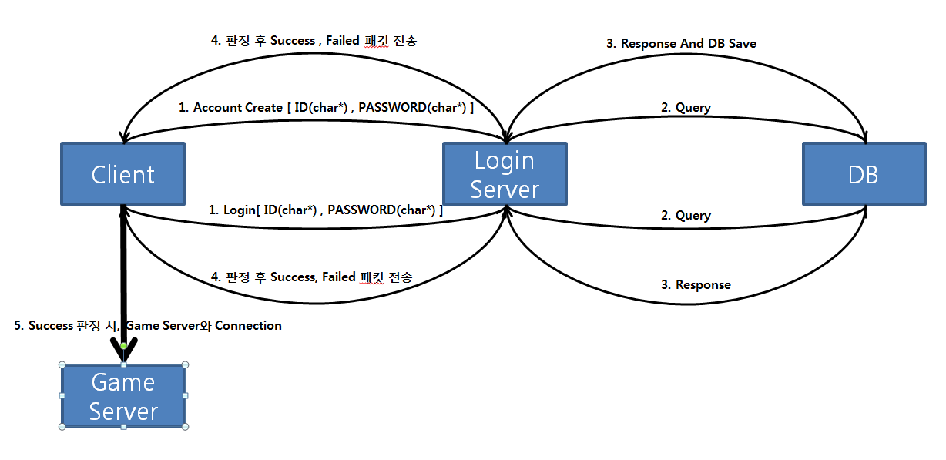● 최초 Client – Login Server 연결 시,

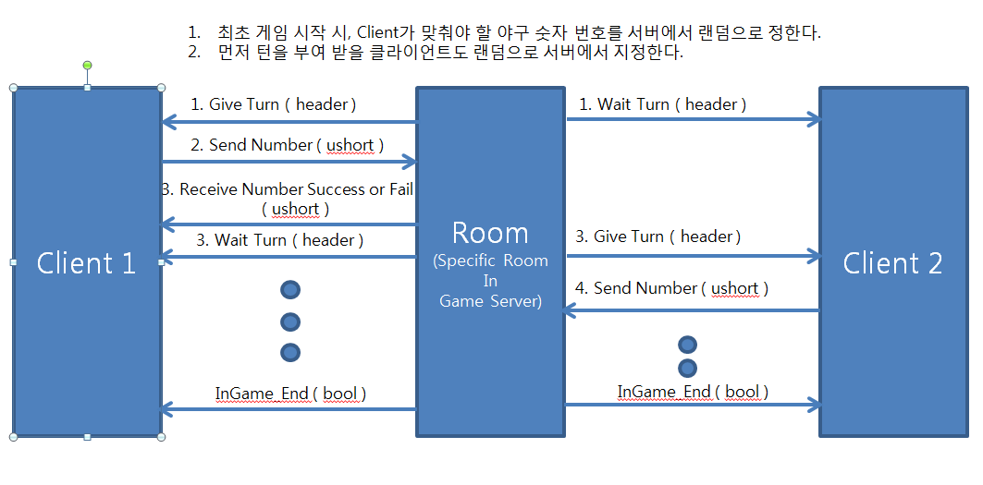● In-Game Flow